Bio for Paul W Esposito
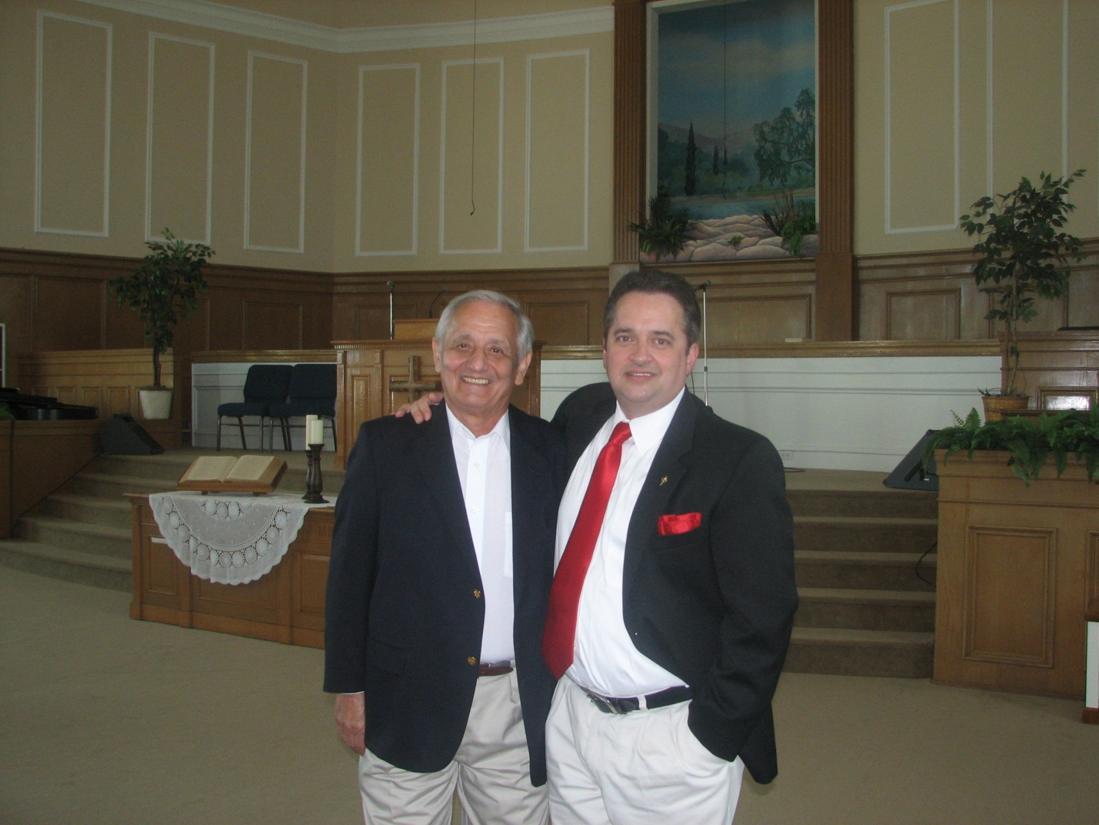

Paul Esposito was born in Summit, New Jersey, in 1963.
He has been an active member in the body of Jesus Christ since 1995 (“When I gave my life back over to Christ Jesus, my Savior.”)
After starting school at Moody Bible Institute, he obtained his Bachelor’s Degree in Biblical Studies from Brevard Christian University, in Cocoa, Florida. Currently he is working on his Master in Church Administration, and Ph.D is in the near future as well.
Mostly self‐taught in the Scriptures, and in Textual Criticism, Esposito felt the Holy Spirit’s calling to learn the original Koine Greek that the New Testament was written in.
“I started with the very basic ‘how‐to 101’, and progressed from there, to fluently reading, writing, and speaking Koine Greek. And that was some 12 years ago.”
Currently, Esposito, the President and founder of Stauros Ministries, has translated both the Greek Old Testament (The Septuagint—The Apostles’ Bible), as well as the New Testament (The EMTV). Both works have been published by Author House, Lulu, and now Amazon, and are very popular, mostly by word of mouth.
Esposito is also a Bible teacher and expositor, teaching the New Testament verse by verse on his radio program, as well as podcasting (programs available at www.gospelstudy.net). He is also a bi-vocational Pastor/Bible teacher, using his teaching gifts in the Church.
In the works is a King James Version/EMTV Interlinear Bible, as well as The Esposito Study Bible, pairing the Apostles’ Bible Septuagint with the EMTV New Testament.
Mr. Esposito has been married to his wife CJ now for 7 years; and she serves as the Vice President of Stauros Ministries.

